

**Vardhaman College of Engineering**

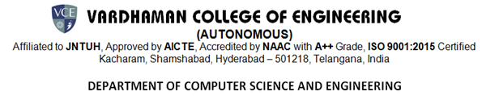

|  |  |
| --- | --- |
| **BATCH ID** |  |
| **Guide Name & Designation** | Rame Swetha  Assistant Proffesor |
| **Title of The Mini Project** | IPL SCORE PREDICTION USING  DEEP LEARNING |
| **Domain** | HPC |

|  |
| --- |
| **ABSTRACT**  IPL score prediction using deep learning is an advanced analytical approach that leverages historical and real-time match data to forecast scores with high accuracy. Traditional statistical methods often fail to capture the complexities of the game, whereas deep learning models, including neural networks, recurrent neural networks (RNNs), and long short-term memory (LSTM) networks, can process large datasets and identify hidden patterns effectively. This study incorporates multiple factors such as team performance, player statistics, pitch conditions, weather, and live ball-by-ball updates to dynamically predict match scores. By providing real-time insights, the model not only enhances score predictions but also assists teams, analysts, and fantasy league players in making strategic, data-driven decisions. Additionally, this predictive system contributes to improving fan engagement by offering more accurate match forecasts, enabling better anticipation of game progress. The integration of deep learning in sports analytics revolutionizes the way cricket is analyzed, making it a valuable tool for players, coaches, and enthusiasts. |

|  |  |  |  |
| --- | --- | --- | --- |
| S NO | ROLL NO | NAME | SIGNATER OF THE STUDENT |
| 1 | 22881A0542 | P. Varun Teja |  |
| 2 | 22881A0562 | V. Sujith |  |
| 3 | 23885A0502 | G. Parinitha |  |

SUPERVISOR MINI PROJECT INCHARGE MINI PROJECT COORDINATER